Alexander Baldree
09/12/26
Module 7.2 Assignment
CSD440

GitHub Link:
https://github.com/Panda-Alex21687/CSD440

AlexForm.html:
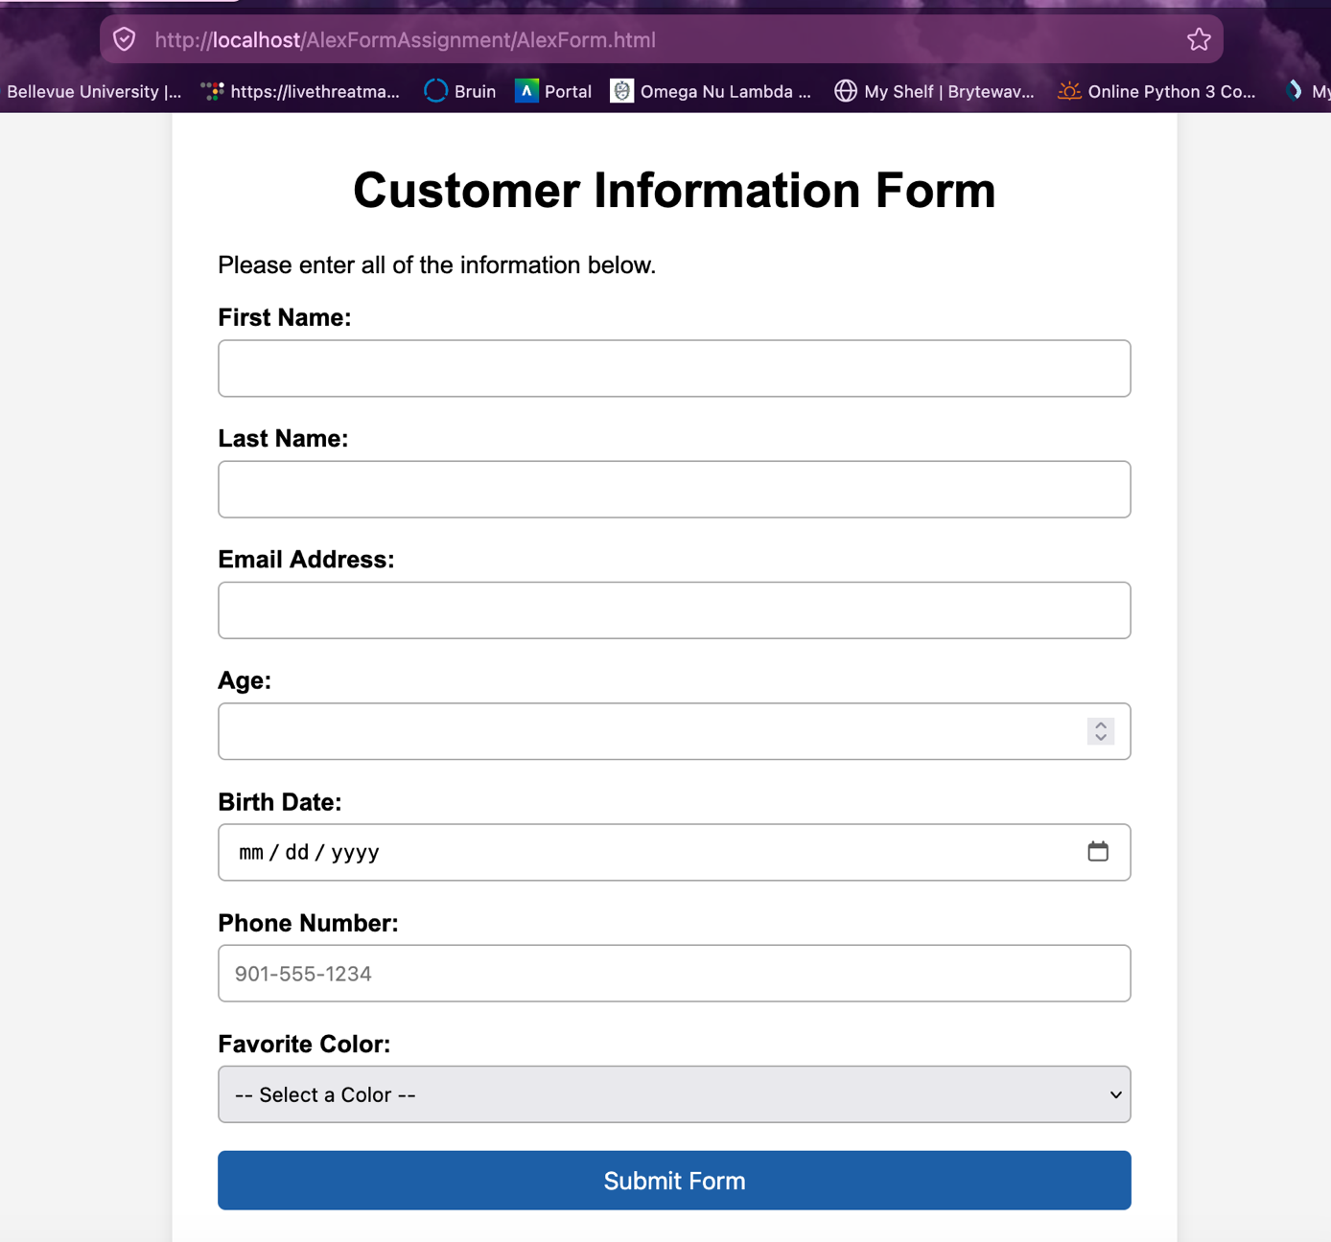

Completed Form:
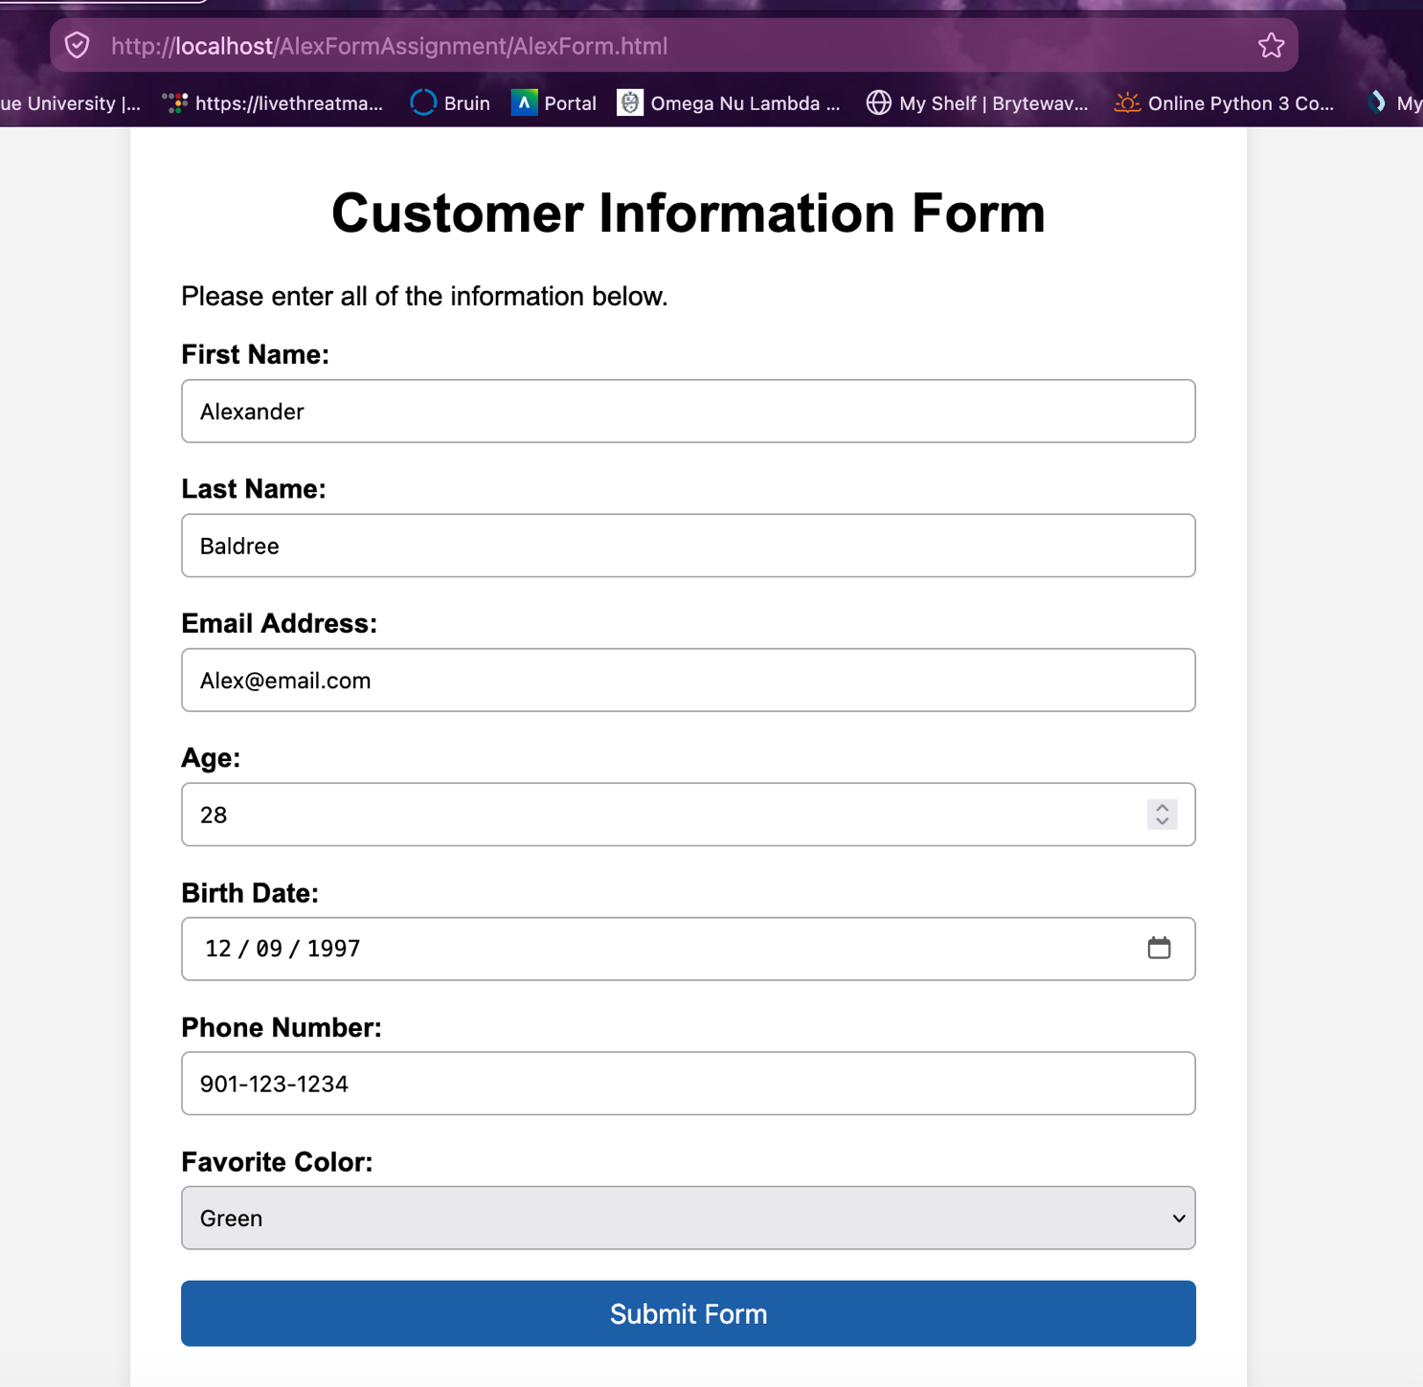

Successful Form Filled out:
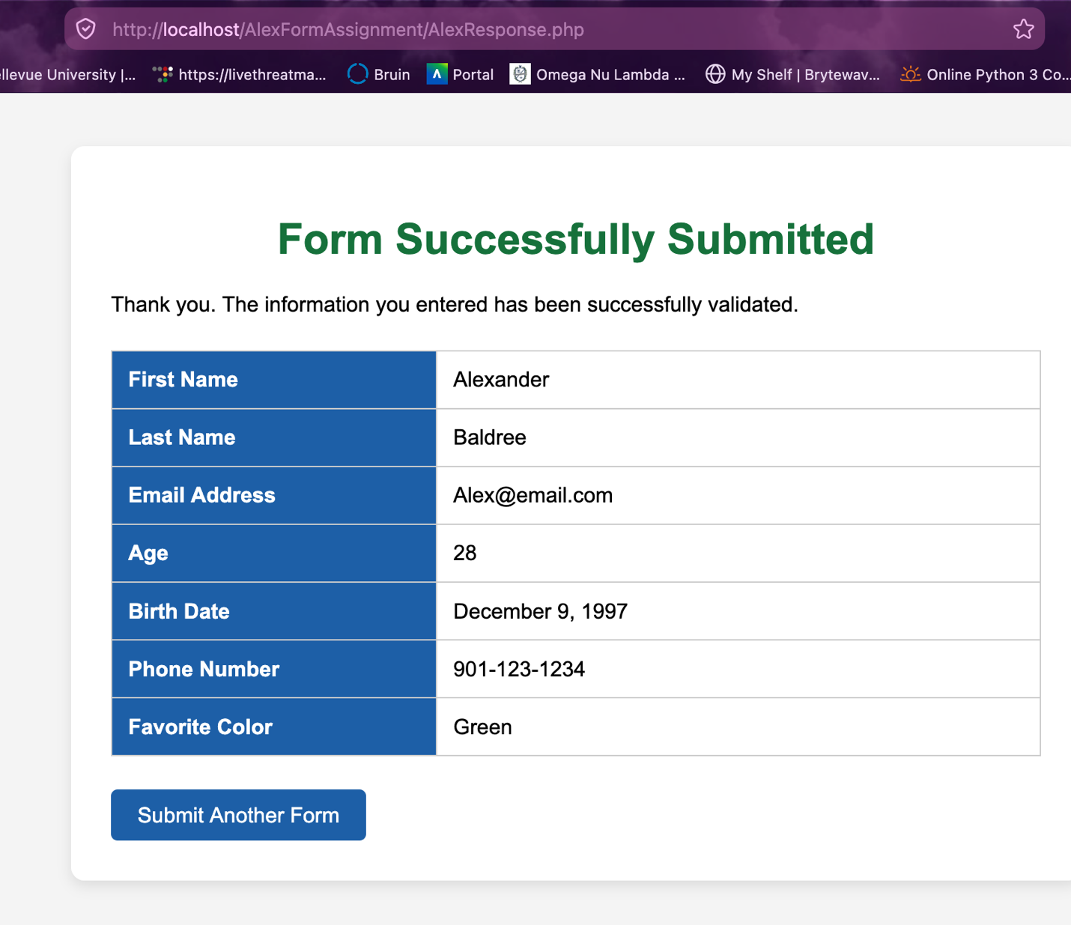

Incorrect Information Filled On Form:
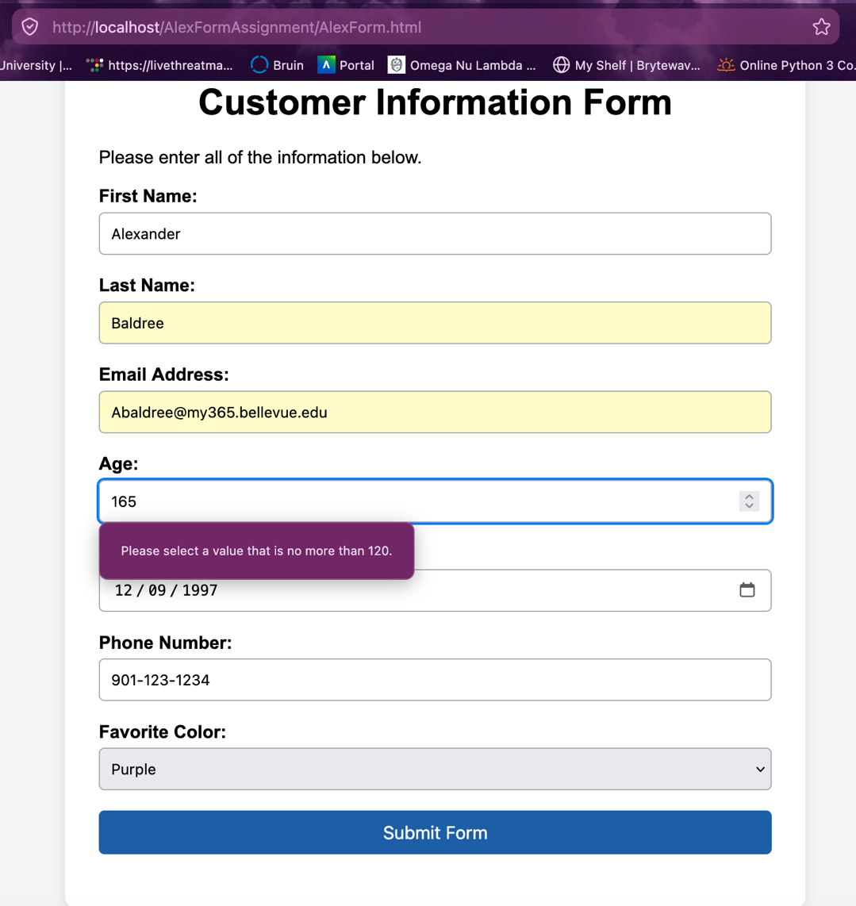

More ERRORS:
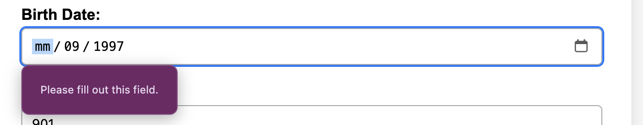
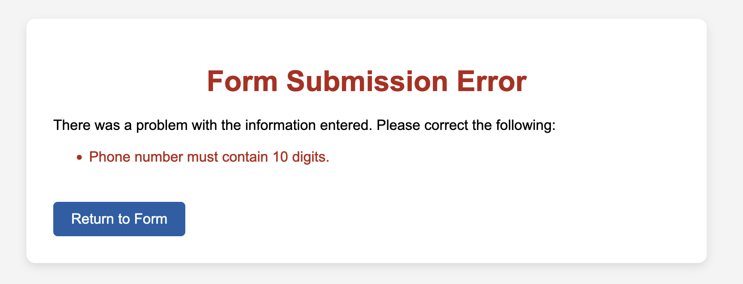

Code for Assignment submitted with word document

